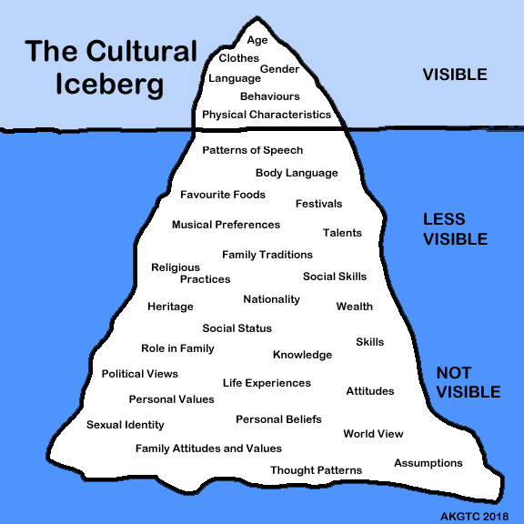
- This graphic represents a "cultural iceberg", a model developed based on anthropologist Edward T. Hall's theory of culture. Imagine that this iceberg represents our culture(s) - there are "surface" or external cultural elements that we regularly put on display (about 10%), and there are cultural elements that are more internal and sometime subconscious. Elements of ourselves that belong to deep culture are not always obvious, even to us.
Respond to the following questions bringing in sociological terms from the module materials.
- Discuss both external and internal elements of your culture(s) using this model as a guide (you can bring in 2-3 examples for each).
- Further reflecting on this model, provide an example of real and ideal culture from your culture(s).
- How does this model help us approach and engage with cultures that are different from ours?

- First, watch the music video of Childish Gambino's "This is America" (TW: Gun Violence).
https://youtu.be/VYOjWnS4cMY

- What forms of identity and symbolism did you see within the music video ?

- Then, watch the breakdown video that explains the hidden symbolism and forms of cultural identity in the music video This is America by Childish Gambino.
- https://youtu.be/9_LIP7qguYw

- Compare your list and note what things you were able to identify and what things you missed, discussing the message in the video about real versus ideal culture in the USA.

- Watch the video below and discuss the following questions:
https://youtu.be/gCj_VhLgcmY

- Is McDonaldization a good thing for college/universities or the career field you are interested in or currently employed in?
- How does it affect the way we learn or do our jobs?
- Is it a good thing for society? For example, Sociologist George Ritzer believed (as did Max Weber who spoke in terms of rationality) that the McDonaldization of society has cost us in the form of originality and creativity. He says we have paid a price for our devotion to uniformity, calculability, efficiency, and automation. What do you think?
- How will it affect the future of our societies?

- Post an example of risky shift (you can share a screen shot or url for twitter, instagram, facebook, YouTube...) and discuss why/how you believe the group dynamics contributed to people engaging in this risky/extreme behavior.
For example, the No Pants Subway Ride has become an international phenomenon in which people ride the subway one day a year without pants. While many individuals would probably not do this alone or even in a small group, they likely feel safe to do it in a large group because:
- they know that police and other officials will probably not bother to respond to public indecency calls on that day,
- they will not be viewed as needing mental health assistance (possibly putting a job or custody of a child in jeopardy), and
- those who are offended by the behavior are less likely to confront large groups.
https://youtu.be/ZVYrG7Hfu1Q

